# PF lab 4 Tasks (3)

**Name: Hassan Ali Khan**

**Roll No: 25K-0516**

**Section: BCS-1K**

**Task 1**

#include<stdio.h>

int main()

{

int age;

printf ("Enter your age\n");

scanf ("%d",&age);

if (age>=18)

{

printf ("Eligible\n");

}

else

{

printf ("Not eligible\n");

}

return 0;

}

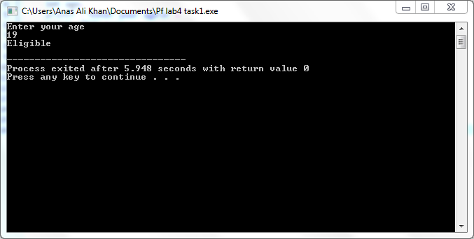

**Task 2**

#include<stdio.h>

int main()

{

int num;

printf ("Enter a number\n");

scanf ("%d",&num);

if (num%2==0)

{

printf ("Number is even\n");

}

else

{

printf ("Number is odd\n");

}

return 0;

}

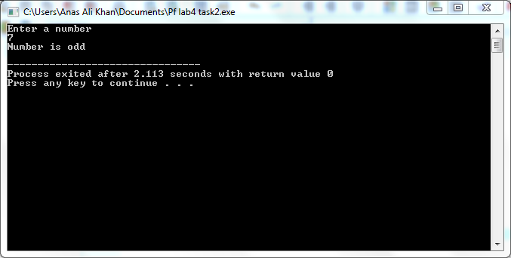

**Task 3**

#include<stdio.h>

int main()

{

int num1,num2,num3;

printf ("Enter three numbers\n");

scanf ("%d%d%d",&num1,&num2,&num3);

if (num1>num2 && num1>num3)

{

printf ("%d is greatest\n",num1);

}

else if (num2>num1 && num2>num3)

{

printf ("%d is greatest\n",num2);

}

else

{

printf ("%d is greatest\n",num3);

}

return 0;

}

